CIS-351:Software Engineering

Final Project

Cody Worswick

**Table of Contents**

1. Introduction 3

2. USER CHARACTERISTICS 4

3. Requirements Determination 5

3.1. literature review 5

3.2. Interview 9

3.3. Questionnaire 11

4. Specific Requirements 14

4.1. User Requirements 14

4.2. System Requirements 14

4.3. NON-FUNCTIONAL Requirements 16

5. System Models 19

5.1. Sequential Diagrams 19

5.2. Conceptual Diagram 20

5.3. Class Diagram 21

6. References 22

# 

# **Introduction**

Welcome to the New You Salon this document will be your one-stop-shop reference material for your salon management system. Just one page back you will find the Table of Contents which will lead you to whatever you need to find. In this reference material, you will find requirements, questionnaires, models, and references. Everything you need to know about your management system can be found by going to the table of contents and finding the right page and sub-category.

# 

# 

# 

# 

# 

# **USER CHARACTERISTICS**

Our users came from various backgrounds and varying experience levels and will have different levels of access.

**CX** will be purely for customers.

**Licensed MG** will be for Managers.

**Licensed** will not have completed high school but will have completed cosmetology school.

**IT (in training)** will be still in training for and have their license.

**Licensed HS** will be licensed and have a high school degree (or GED) and have their license. **Licensed CG** will be for those who have completed college and have their license.

Users will also be broken down by their experience level the level will be marked by years of experience starting on year 0 for those in training.

Users will also be broken down by the services they can provide and their level of expertise:

Users in training or 0 years of experience can provide the following services:

* **blow-drying**
* **styling**
* **washing**

Users with their license can provide the following services:

* **blow drying**
* **styling**
* **washing**
* **single-process color**
* **haircuts**

Users with their license and 1-year experience can provide the following services:

* **blow drying**
* **styling**
* **washing**
* **single-process color**
* **haircuts**
* **highlights**
* **relaxer**
* **perms**

Users with their license and 2-year experience can provide the following services:

* **blow drying**
* **styling**
* **washing**
* **single-process color**
* **haircuts**
* **highlights**
* **relaxer**
* **perms**
* **color corrections**
* **balayage**
* **keratin treatment**

**Requirements Determination**

**Literature** **Review**

Every website has its own flair and design choices you can find below a review of some competitors' websites and what features they offer through the website.

**Shear Illuzionz** has a very barebones website that lists their:

* A short introduction
* Picture of the staff
* Links to Social media
* Contact information
  + location
  + Hours of operation
* Services offered
  + The estimated prices for services

(*Shear Illuzionz*, 2017)

**Pavia Salon** has a nice looking site with a good landing page. The first thing you see is a big button to book appointments. Followed by examples of the salon's previous work via social media posts. Then you are given an introduction to the studio. This is a great site and a good example of what we should be aiming towards.

Features of this site:

* Easy online booking
* Option to send an email to staff directly through the website
* Employees profiles
* Direct link to email flyer
* Gallery of past works
* Product recommendations
* Allows customers to have their own accounts
* Contact information
* Services offered
  + The estimated prices for services

(Privai, 2022)

**Sage Tryall Salon** is overall a good site it's missing some of the key features we need on our site like online booking for appointments. The site does offer

* Employee profiles
* Contact information
  + location
  + Hours of operation
* Links to social media
* Services offered
  + The estimated prices for services
* Rewards program
  + Gift cards
* Gallery of past works
  + sorted by employees
* Product shop

(*Sage Tryall Salon – An Intercoiffure Salon*, 2018)

**Maven Salon** has a very snappy website that lends itself to easy access and use. They have many of the features we are looking for in our system. All features they offer are:

* Online booking
* Services offered
  + The estimated prices for services
* Contact information
  + location
  + Hours of operation
* Gallery of past work
* Quick email message
* Links to social media
* Employee profiles
  + Links to employee social media

(*Maven Salon*, 2021)

**Privai** has a good example of what not to do. The Privai system is over complicated and very wordy in places. We need something much cleaner and easy to navigate. The features on their website are:

* Online booking
* Services offered
  + The estimated prices for services
* Contact information
  + location
  + Hours of operation
* Live chat
* Online store
* Links to social media
* Quick email message
* Gift cards
* FAQ

(*Pavia Salon*, 2021)

**Stakeholder Interview**

We need to understand what is needed for our system to be the best that it can be. We have a series of questions to ask intended to find the needs of the system.

* What are the goals, values, and vision of your company?
* What are your growth metrics for the next 1, 5, and 10 years?
* What problem does your product solve and how commercially viable is it?
* What is your budget?
* What are your USPs (unique selling points)?
* Who are your users?
  + What are you trying to help them achieve?
* Who are your competitors?
  + What do you like about them?
* What is the research that has already been done?
* What do you need your system to have?
* How should the system look to you?
* Are there any design constraints?
  + If yes, what are they?
* Are there any technology constraints?
  + If yes, what are they?
* What are the deadlines for the project?
* What is the process of approval for design and who will be approving them?

We had a very productive interview with the stakeholders to get all their wants and needs for their management system in order. In the interview, it was determined that the system needs to:

* Allow customers to book appointments.
  + The stakeholders made it clear that this is a major priority
* Allow the manager
  + to add/delete a specialist.
  + to assign a specialist to a particular service.
  + to assign a specialist to a time slot.
* Allow the specialist
  + to update their own profile.
* Allow the customer
  + to view the catalog and the offers that the salon has.
  + to view the available specialists’ profiles.

Stakeholders made it loud and clear that they want the ability for customers to book online. This will save them from constantly manning the phones. It's clear from the interview that the managers should have high-level access to the system and be able to make any changes deemed necessary. While allowing specialists to have control over their profile pages. So they can customize them and link their social media platforms to their profiles. Customers should also have access to view the salon’s catalog and see which specialists would be right for them.

**Questionnaire Questions**

* Have you ever used a management system before?
* Which kind of system management system do you prefer?
* How many years of experience do you have?
* What is your role?
* Are you satisfied with the existing System?
* Write down your suggestion

|  | Employees | Stasi | Julissa | Annie | Bubbles | Cody | Tiffany | Hillary |
| --- | --- | --- | --- | --- | --- | --- | --- | --- |
| Questions |  |  |  |  |  |  |  |  |
| Have you ever used a management system before? | Y/N | Y | Y | Y | Y | N | Y | Y |
| Which kind of system management system do you prefer? | Simple, easy to operate  Complex but complete function | Complex | Simple | Simple | Simple | Simple | Simple | Complex |
| How many years of experience do you have? | # | 15 | 12 | 13 | 1 | 0 | 2 | 3 |
| What is your role? | MG, IT, Licensed, Licensed HS, Licensed CG | MG | Licensed HS | Licensed HS | Licensed CG | IT | Licensed CG | Licensed CG |
| Are you satisfied with the existing System? | Y/N | N | N | N | N | N | N | N |
| Write down your suggestion |  | social media Connection | I want to be able to show my art to the world | quickly answer customers’ questions via chat | I think we should have Gift cards | I think we should have our profiles linked to social media | I think we should have a reward program | I think we should have Which person provide which services |

| Questions | Results |
| --- | --- |
| Have you ever used a management system before? | 6/7 Yes |
| Which kind of system management system do you prefer? | 5/7 Simple |
| How many years of experience do you have? | 3/7 over 10 years rest are 3 years or under |
| What is your role | 6/7 Licensed 1 in training |
| Are you satisfied with the existing System? | 0/7 |

From these results we can draw a few different things.

1. Almost all have used a Management system before.
2. Most prefer to have a simple system that is easy to use.
3. We have a wide gap between levels of experience among employees.
4. All but one are trained Cosmetologists.
5. No one is satisfied with the current system.

**4. Specific Requirements**

**User Requirements**

* Allow customers to book appointments.
* Allow the manager to add/delete a specialist.
* Allow the manager to assign a specialist to a particular service.
* Allow the manager to assign a specialist to a time slot.
* Allow the specialist to update their own profile.
* Allow the customer to view the catalog and the offers that the salon has.
* Allow customers to view the available specialists’ profiles.
* Allow customers to quickly message the salon and get an email response.
* Allow specialists to upload pictures to their gallery.
* Allow specialists to have their profiles linked to their social media.
* Allow customers to purchase products from the site.

### **System Requirements**

* The system shall Use SQL to manage the database
* The system shall do validity checks on the inputs
* The system shall save the previous month’s system as a backup
* The system shall exact sequence of operations
* The system shall provide responses to abnormal situations, including
  + Overflow
  + Communication facilities
  + Error handling, and recovery
* The system shall allow the relationship of outputs to inputs, including
  + Input/output sequences
  + Formulas for input to output conversion
* User requirements
  + The system shall have users required to put in username and password to allow access to the specialist portal.
  + The system shall allow users to reset passwords.
  + The system shall allow users to recover user names to email or phone numbers.
  + The system shall allow the customer to view the catalog and the offers that the salon has.
  + The system shall Allow customers to book appointments.
  + The system shall allow the manager to add/delete a specialist.
  + The system shall allow the manager to assign a specialist to a particular service.
  + The system shall allow the manager to assign a specialist to a time slot.
  + The system shall allow the specialist to update their own profile.
  + The system shall allow customers to view the available specialists’ profiles.
  + The system shall allow customers to quickly message the salon and get an email response.
  + The system shall allow specialists to upload pictures to their gallery.
  + The system shall allow specialists to have their profiles linked to their social media.
  + The system shall allow customers to purchase products from the site.

### **Nonfunctional Requirements**

* What are the factors required to establish the required reliability of the software system at the time of delivery?
  + **Flexibility and Extensibility-** The system must be able to add/modify/remove functionality without damaging the current system.
  + **Maintainability and Readability-**  The system must be easily maintained allowing for minor changes with little effort.
  + **Performance and Efficiency-** The system must function at a consistent level.
  + **Scalability-**  The system must allow for the system to be scaled to need.
  + **Usability and Accessibility-** The system must be easy to learn and use.
  + **Security-** The system must be secure to make sure user data is not accessed by 3rd parties.
  + **Functionality-** The system must meet all functional requirements.
* What are the factors required to guarantee a defined availability level for the entire system such as checkpoint, recovery, and restart?
  + Allow for the system to have checkpoints. This will allow for the system to restart or recover from a previous checkpoint and try to start over. This will improve availability.
* What are the factors required to protect the software from accidental or malicious access, use, modification, destruction, or disclosure?
  + Avoid the introduction of accidental errors into the system during software specification and development.
  + Design verification and validation processes that are effective in discovering residual errors that affect the dependability of the system.
  + Design the system to be fault-tolerant so that it can continue working when things go wrong.
  + Design protection mechanisms that guard against external attacks that can compromise the availability or security of the system.
  + Configure the deployed system and its supporting software correctly for its operating environment. 6. You include system capabilities to recognize external cyberattacks and resist these attacks.
  + Design systems so that they can quickly recover from system failures and cyberattacks without the loss of critical data

(Ian, 2015)

* What are the different attributes of software that relate to the ease of maintenance of the software?
  + Iterative development and regular reviews to improve quality
  + Keeping the code Readable and easy to understand
  + Refactor code to improve its understandability
  + Relevant documentation
  + Automated build to make the code easy to compile
  + Automated tests to make it easy to validate changes
  + Continuous integration makes the code easier to build and test
  + Version control helps keep code, tests, and documentation up to date and synchronized
* What is the speed, availability, response time, recovery time of various software functions?
  + Speed: Processed transactions/second User/event response time Screen refresh time
  + availability: is the amount of time the system is available also known as uptime.
  + response time: the amount of time the system takes to return the results of a request to the user.
  + recovery time: is how long it takes to get the system back up after it goes down.

**5. SYSTEM MODELS**

**5.1. SEQUENTIAL DIAGRAMS**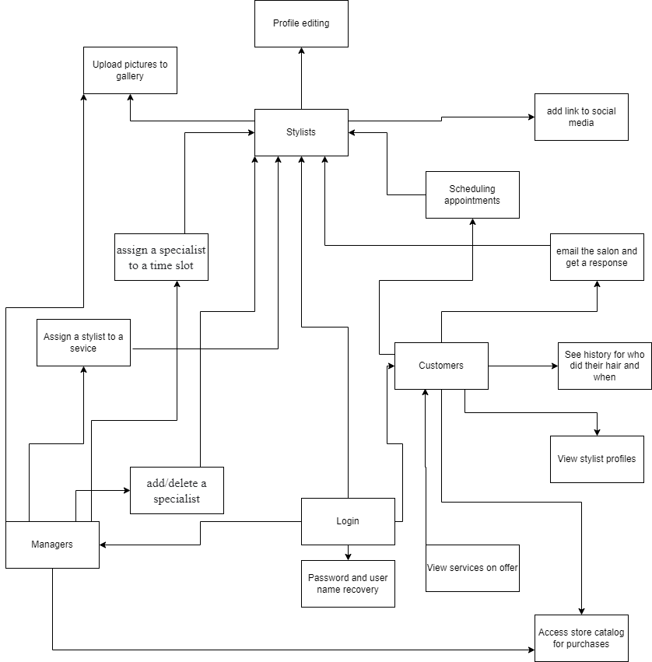

**5.2. CONCEPTUAL DIAGRAM**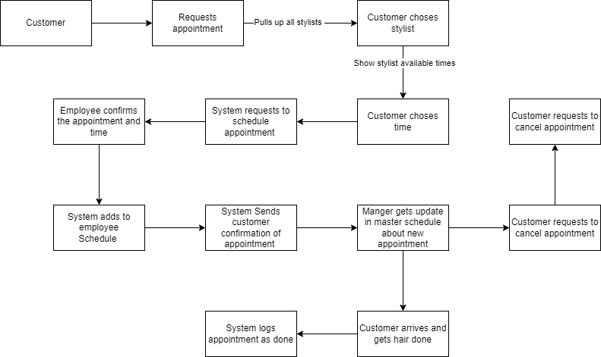

**5.3. CLASS DIAGRAM**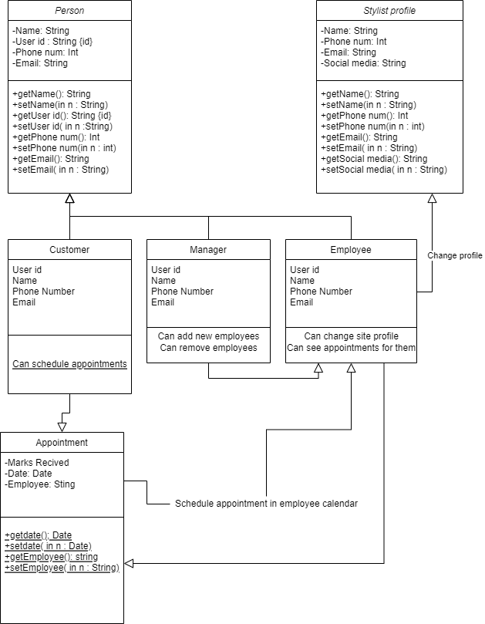

References

*Maven Salon*. (2021). Maven Salon. Retrieved March 3, 2022, from https://www.mavensalon.com/

*Pavia salon*. (2021). Pavia Salon. Retrieved 2022, from https://paviasalon.com/

Privai. (2022, February 22). *Privai*. https://privai.com/fairfax-corner/#1634847962503-39d3486a-213e

*Sage Tryall Salon – An Intercoiffure Salon*. (2018, April 4). Sage Try All Salon. http://www.sagetryallsalon.com/

*Shear illuzionz*. (2017). Shear Illuzionz. <https://www.shearilluzionz.com/>

Ian, S. (2015). *Software Engineering Global Edition* (10th ed.). PEARSON EDUCACION.